Project Proposal: Car Workshop Management System
Submitted By : Hamdan Yasir & Hudaibia Rehman
Submitted To : Sir Ali Hassan
Subject : Database Management System (Lab)
Class & Section : BSSE GROUP A
Semester : IV
GITHUB LINK: https://github.com/hamdanyasir619-maker/DBMS-CAR-WORKSHOP.git

Milestones
V1.0 • ERD Diagram
V1.1 • Flowchart And Schema

ERD (Entity Relationship Diagram)
🔹 Main Entities & Relationships
• Customer → Vehicle (1:M)
• Vehicle → ServiceJob (1:M)
• Mechanic → ServiceJob (1:M)
• ServiceJob → Invoice (1:1)
• ServiceJob ↔ SparePart (M:N via ServiceParts)

• ERD DIAGRAM:

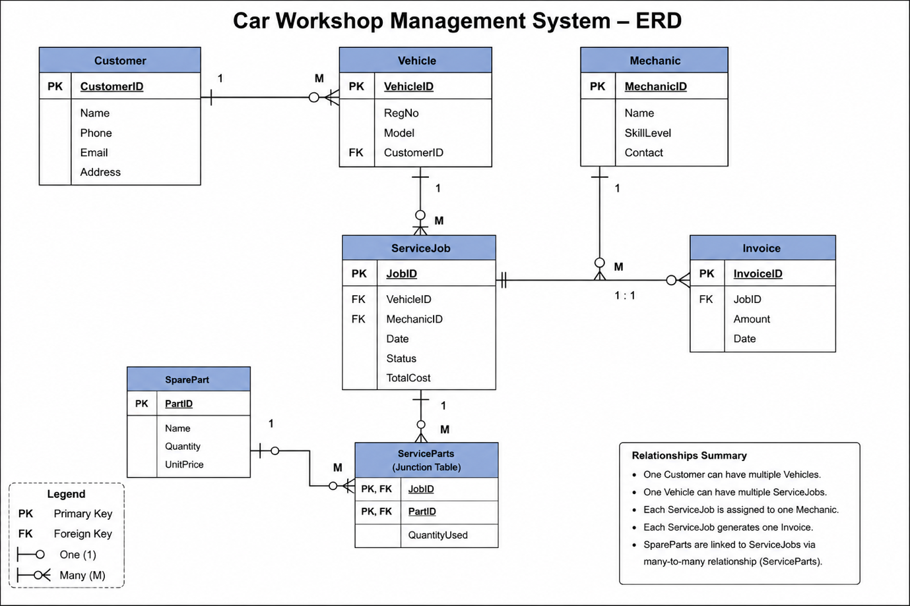

FLOWCHART:

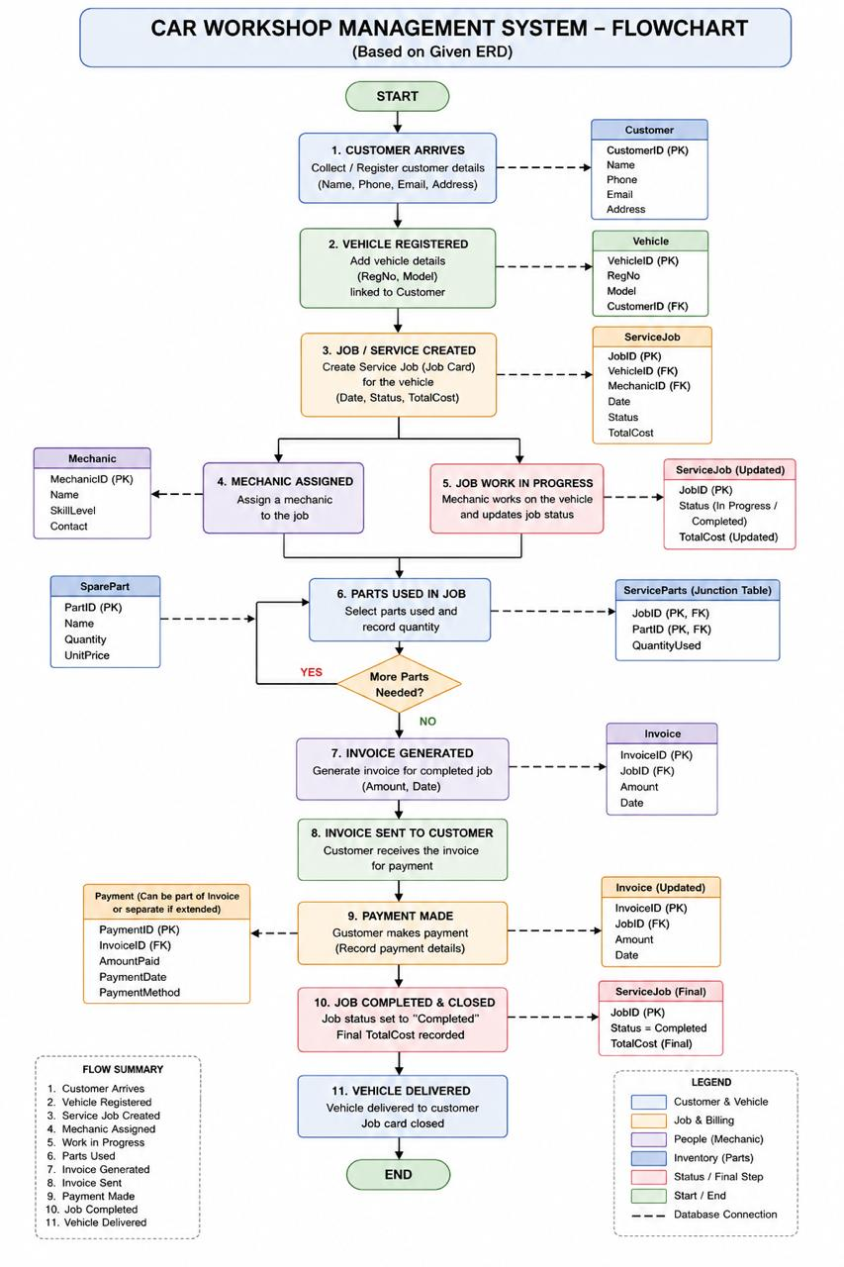

Entities with Attributes
Customer
• CustomerID (PK)
• Name
• Phone
• Email
• Address
Vehicle
• VehicleID (PK)
• RegNo
• Model
• CustomerID (FK)
Mechanic
• MechanicID (PK)
• Name
• SkillLevel
• Contact
ServiceJob
• JobID (PK)
• VehicleID (FK)
• MechanicID (FK)
• Date
• Status
• TotalCost
SparePart
• PartID (PK)
• Name
• Quantity
• UnitPrice
Invoice
• InvoiceID (PK)
• JobID (FK)
• Amount
• Date
ServiceParts (Junction Table)
• JobID (FK)
• PartID (FK)
• QuantityUsed

Keys & Relationships Explanation
• Primary Keys (PK): Unique identifiers (CustomerID, VehicleID, etc.)
• Foreign Keys (FK): Can be multiple.
• Vehicle.CustomerID → Customer.CustomerID
• ServiceJob.VehicleID → Vehicle.VehicleID
• ServiceJob.MechanicID → Mechanic.MechanicID
• Invoice.JobID → ServiceJob.JobID
• ServiceParts.JobID → ServiceJob.JobID
• ServiceParts.PartID → SparePart.PartID

Milestone 2: ERD Design & Normalization
Step 1: Apply Normalization
1. Customer Table
• Original: CustomerID (PK), Name, Phone, Email, Address
• 1NF: Split Name into FirstName and LastName. Split Address into Street, City, State, and ZipCode.
• 2NF: Satisfied. The primary key (CustomerID) is a single attribute.
• 3NF: Satisfied. No non-key attributes depend on other non-key attributes.
2. Vehicle Table
• Original: VehicleID (PK), RegNo, Model, CustomerID (FK)
• 1NF: Split Model into Make, ModelName, and Year.
• 2NF & 3NF: Satisfied.
3. Mechanic Table
• Original: MechanicID (PK), Name, SkillLevel, Contact
• 1NF: Split Name into FirstName and LastName.
• 2NF & 3NF: Satisfied.
4. ServiceJob Table
• Original: JobID (PK), VehicleID (FK), MechanicID (FK), Date, Status, TotalCost
• 3NF Issue: TotalCost is a derived attribute (calculated from Parts + Labor).
• Change: Removed TotalCost. Added LaborCost. Total cost will be calculated dynamically.
5. Invoice Table
• Original: InvoiceID (PK), JobID (FK), Amount, Date
• 3NF Issue: Amount is a derived attribute.
• Change: Removed Amount. Added PaymentStatus and PaymentMethod.
Step 2: Remove Duplicates
The TotalCost in ServiceJob and Amount in Invoice were redundant and overlapping. Both were removed to satisfy 3NF, ensuring data consistency.
Step 3: Update Your ERD
The Entity-Relationship Diagram was updated to map the normalized schema. All attributes are now atomic, and the final cost calculations will be derived dynamically via application logic.
Milestone 3: Dataset Preprocessing & Dataflow
Step 1: Prepare Your Dataset
As this project requires a relational database to be populated, we generated structured synthetic data.
• Data Generation Strategy: We generated exactly 50 rows of highly realistic dummy data for each of the 7 core tables: CUSTOMER, VEHICLE, MECHANIC, SERVICE_JOB, SPARE_PART, SERVICE_PARTS, and INVOICE.
• Data Quality & Integrity: The synthetic data was strictly structured to ensure referential integrity. CustomerIDs used in the Vehicle data strictly map to the 50 created customers, and JobIDs map correctly to PartIDs in the service parts log.
Step 2: Define Your Dataflow
1. Data Entry Points (Input)
• Customer & Vehicle Intake: A front-desk employee enters the customer's personal details into the CUSTOMER table. Following this, the vehicle details are registered into the VEHICLE table.
• Inventory Restocking: The workshop manager enters parts data into the SPARE_PART table.
• Mechanic Onboarding: Administration inputs employee data into the MECHANIC table.
2. Data Movement & Processing (Throughput)
• Service Job Creation: A new record is created in the SERVICE_JOB table when a vehicle is assigned to a mechanic.
• Parts Consumption: As the mechanic works, entries are logged in the SERVICE_PARTS junction table.
• Labor Logging: Upon job completion, the Status is changed to "Completed" and final LaborCost is logged.
3. Data Output (Output)
• Invoice Generation: The system reads the LaborCost from SERVICE_JOB and joins SERVICE_PARTS with SPARE_PART to calculate total costs, logging it in INVOICE.
• Business Reporting: Management queries the system to extract analytical outputs.
Step 3: Export Clean CSV Files
We exported the generated data into clean .csv format, with one file representing each table in the database schema. These files were staged in the Milestone3/DummyData/ folder.
Milestone 4: Database Setup (DDL)
Step 1: DDL Script Creation
A comprehensive Data Definition Language (DDL) script was created to generate the 7 core tables derived from our finalized normalized schema.
Constraints Implemented:
• Primary Keys (PRIMARY KEY): Applied to all tables. A composite primary key is correctly utilized in the SERVICE_PARTS junction table (JobID, PartID).
• Foreign Keys (FOREIGN KEY): Defined explicit relational mapping between tables ensuring referential integrity. ON DELETE CASCADE is utilized for parent-child relations like Customer-to-Vehicle. ON DELETE RESTRICT is used to prevent the accidental deletion of active Mechanics or Spare Parts.
• Data Integrity (NOT NULL): Applied to core data points such as FirstName, Date, and Status.
• Unique Constraints (UNIQUE): Applied to Email (Customer) and RegNo (Vehicle) to ensure no duplicate entries exist in the system.
• Check Constraints (CHECK): Added robust domain validations.
◦ SkillLevel in Mechanics must be 'Junior', 'Intermediate', 'Senior', or 'Master'.
◦ Status in Service_Job must be 'Pending', 'In Progress', 'Completed', or 'Cancelled'.
◦ Monetary values (LaborCost, UnitPrice) and Quantity strictly enforce zero or positive constraints.
Indexing Implemented:
• Indexes (CREATE INDEX) have been explicitly declared for:
◦ All Foreign Key columns to dramatically speed up join operations and cascaded deletes.
◦ Frequently queried status fields (e.g., PaymentStatus, Status).
◦ Common lookup fields like Email, RegNo, and LastName.
Step 2: Verification Process
The script was structured specifically for full compatibility with MySQL Workbench, ready to be reverse-engineered into an EER Diagram.
Milestone 5: Data Population & Validation
Step 1: Data Loading (DML)
A comprehensive Data Manipulation Language (DML) script was created.
• We utilized standard INSERT INTO ... VALUES ... statements to bulk-insert the synthetic data generated in Milestone 3 directly into the respective MySQL tables.
• This approach populates all 7 core tables with exactly 50 rows of realistic dummy data, avoiding common MySQL local file permission issues.
Step 2: DML Operations
To demonstrate active database management, two explicit data manipulation operations were executed:
• UPDATE Operation: We included a WHERE clause condition to isolate specific rows. Specifically, we updated the SERVICE_JOB table to systematically increase the LaborCost by 10% for any job that is currently marked as 'Pending'.
• DELETE Operation: We successfully executed a targeted delete using a compound WHERE clause, deleting a specific erroneous invoice from the INVOICE table.
Step 3: Validation Queries
Three core validation queries were prepared to prove the integrity of the data load:
1 Count Validation: A COUNT(*) query utilizing UNION ALL across all 7 tables to verify the 50-row benchmarks were hit.
2 Null Constraints Check: A verification query checking the CUSTOMER table for any missing FirstName or Phone entries to prove the data obeys the NOT NULL constraints.
3 JOIN-based Referential Integrity Check: A LEFT JOIN query mapping SERVICE_JOB to VEHICLE to CUSTOMER checking for NULL outputs, ensuring there are zero orphaned records and that the foreign keys maintain perfect structural linkage.

